Week 6 - S6 - Core OOP - Inheritance - Assignment Problem (HW)

Name:Ramesh Harisabapathi Chettiar

Date of Submission:23/09/25

**QNO1🡪**

**Problem Statement:**

**Create Light class with multiple constructors using this(). Create LED class with**

**constructors using both this() and super().**

**Hints:**

**● Chain constructors using this() in same class**

**● Chain to parent using super() from child class**

**● Add print statements to trace constructor calls**

**PROGRAM🡪**

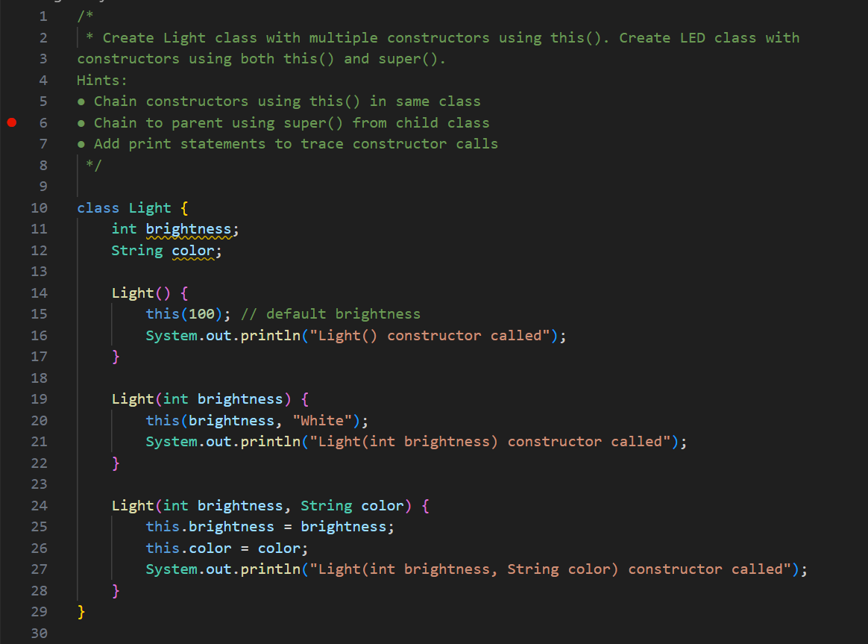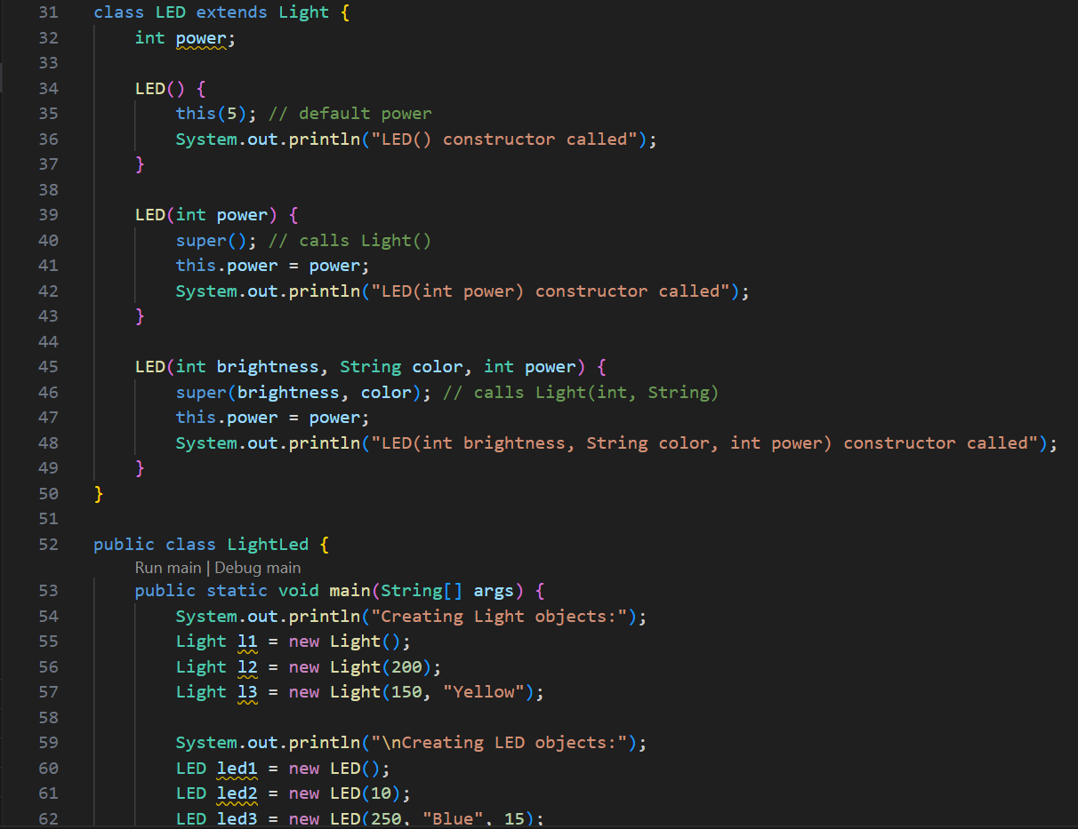

**OUTPUT🡪**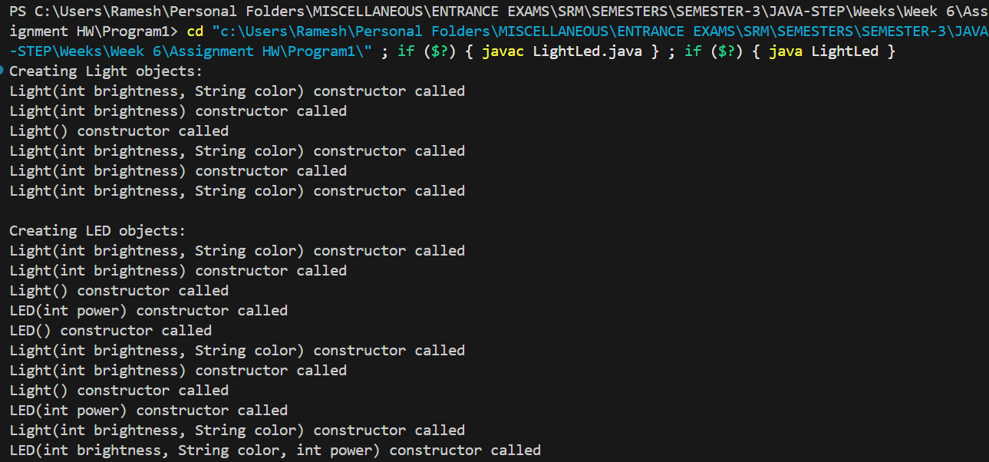

**QNO 2🡪**

**Problem Statement:**

**Create Tool class with private, protected, and public fields. Create Hammer class and**

**test field accessibility.**

**Hints:**

**● Try accessing different access level fields from child**

**● Use getters for private fields**

**● Document which fields are directly accessible**

**PROGRAM🡪**

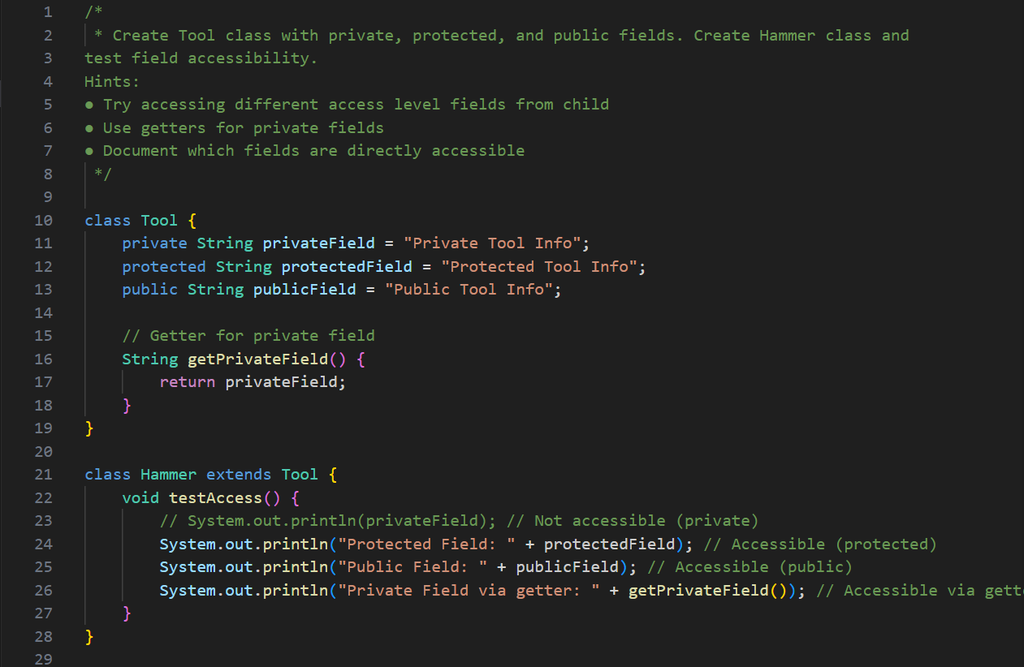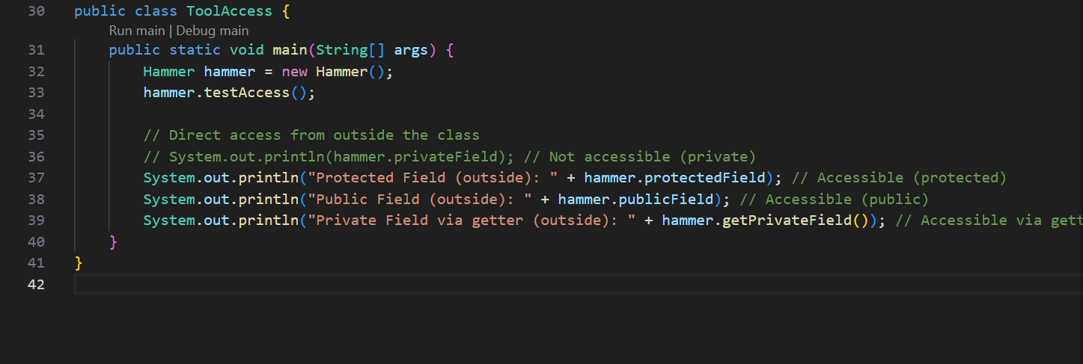

**OUTPUT🡪**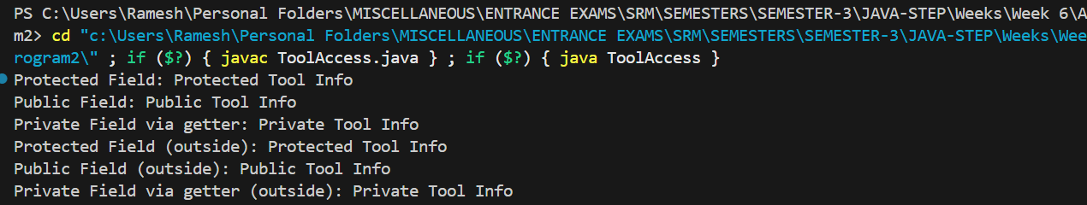

**QNO 3🡪**

**Problem Statement:**

**Create Game class overriding toString() and equals(). Create CardGame extending Game**

**and override these methods properly.**

**Hints:**

**● Override toString(), equals(), and hashCode()**

**● Call super.toString() in child class override**

**● Test equality between objects**

**PROGRAM🡪**

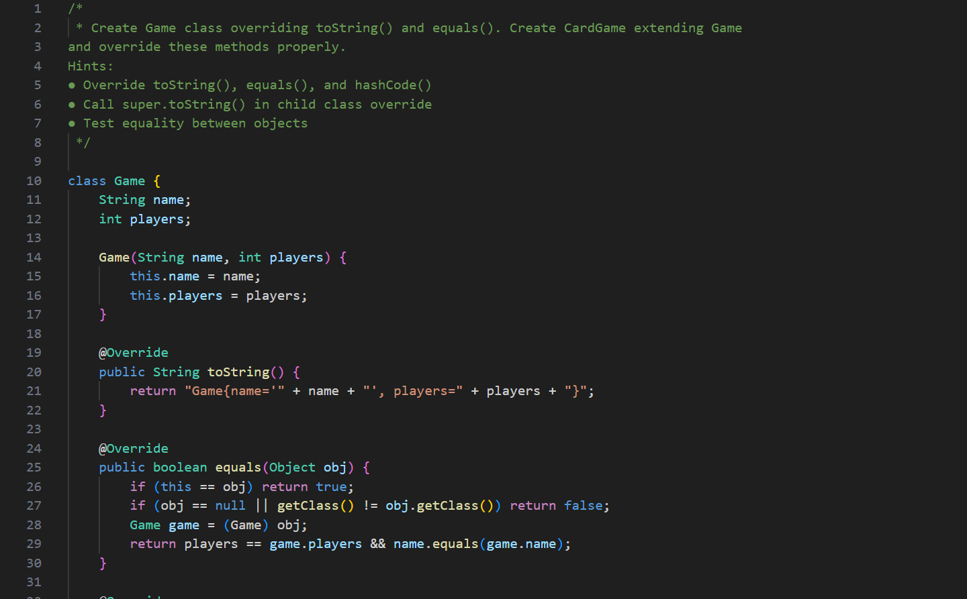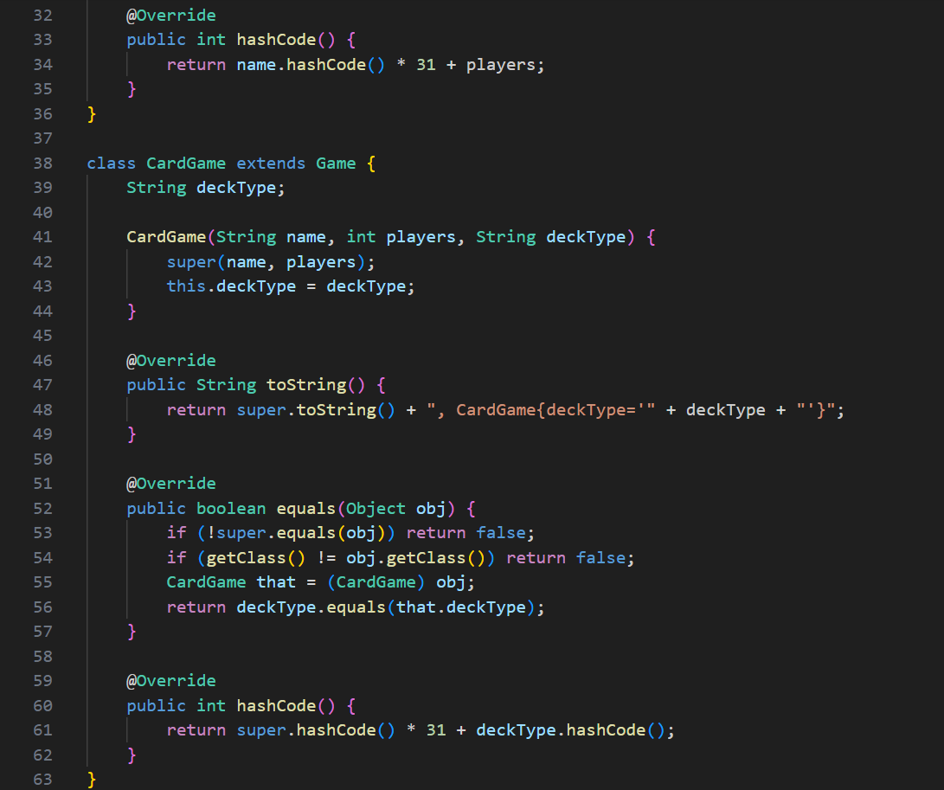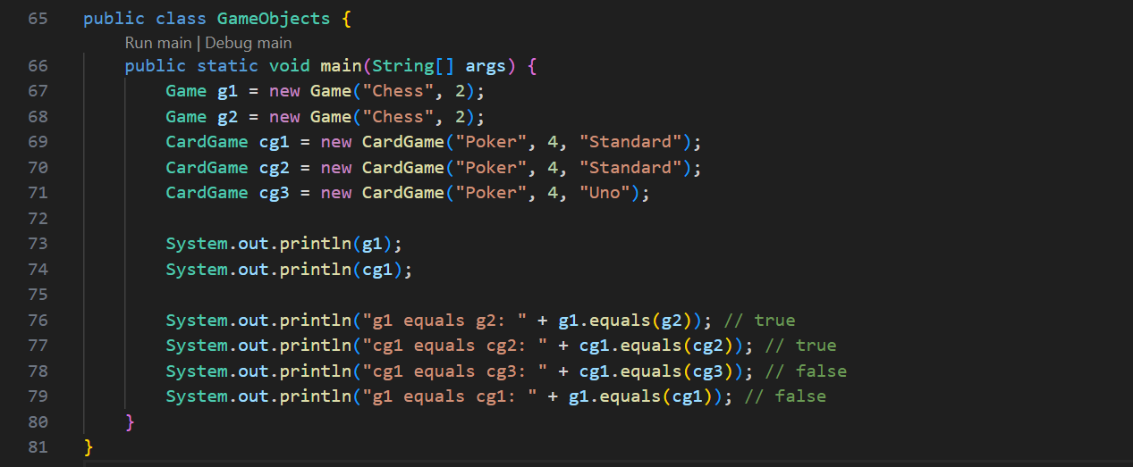

**OUTPUT🡪**

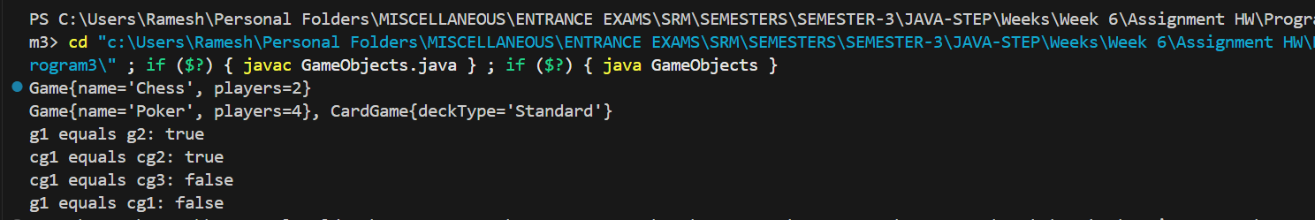

**QNO 4🡪**

**Problem Statement:**

**Create Food class with template method prepare() that calls wash(), cook(), serve().**

**Create Pizza and Soup with different implementations.**

**Hints:**

**● Template method calls other methods in sequence**

**● Child classes override individual step methods**

**● Test template method on different food types**

**PROGRAM🡪**

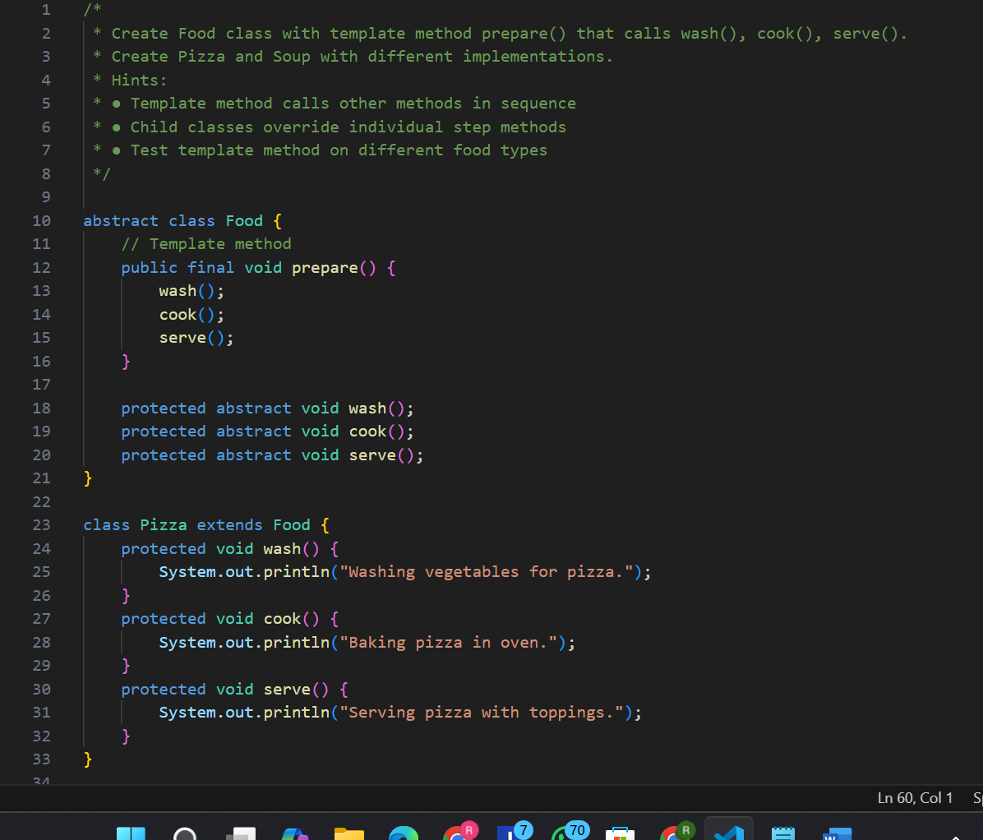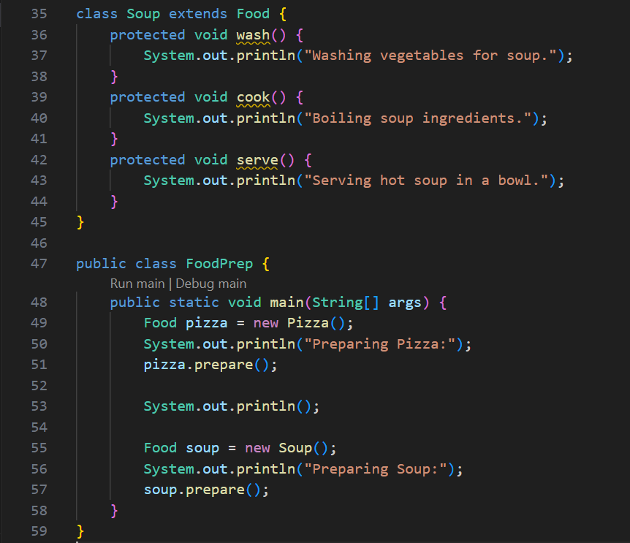

**OUTPUT🡪**

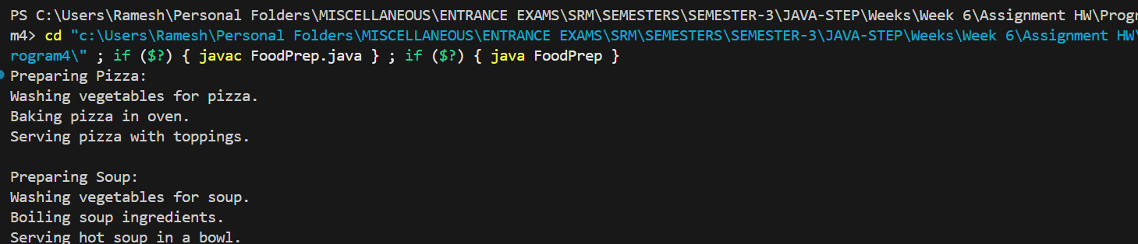

**QNO5🡪**

**Problem Statement:**

**Create BasicMath with overloaded calculate() methods. Create AdvancedMath**

**extending it and adding more overloaded methods.**

**Hints:**

**● Create multiple calculate() methods with different parameters**

**● Child class inherits all overloaded methods**

**● Add new overloaded methods in child class**

**PROGRAM🡪**

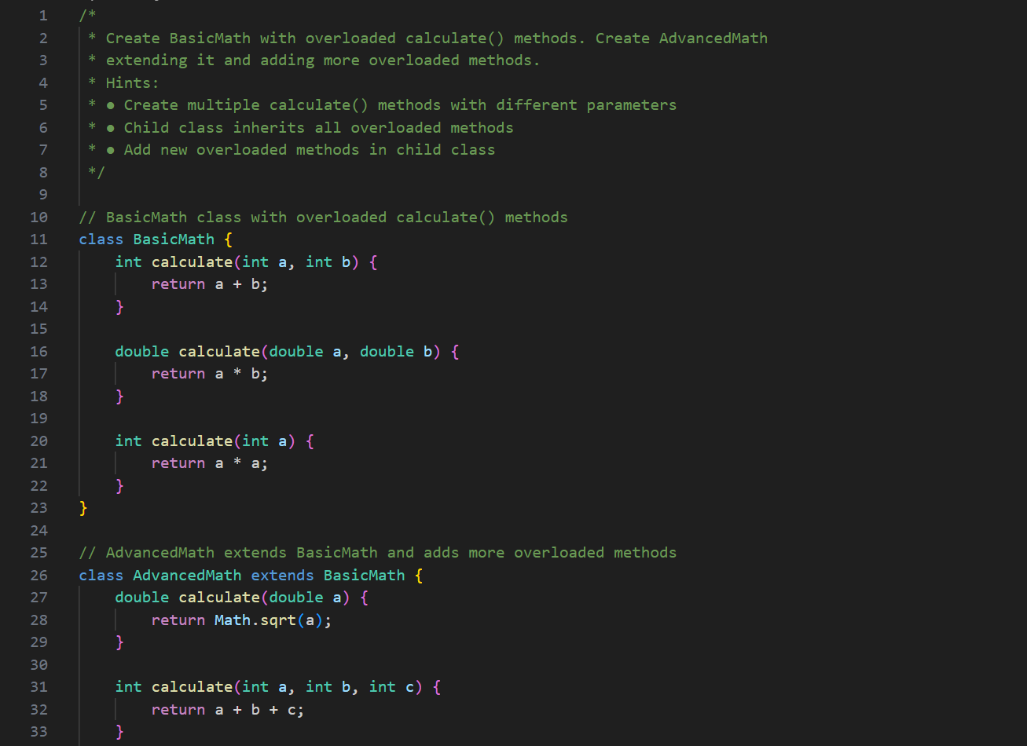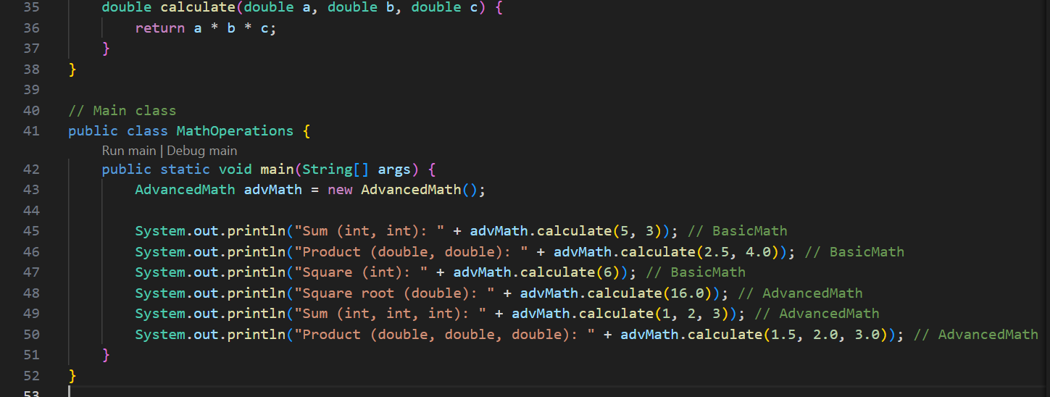

**OUTPUT🡪**

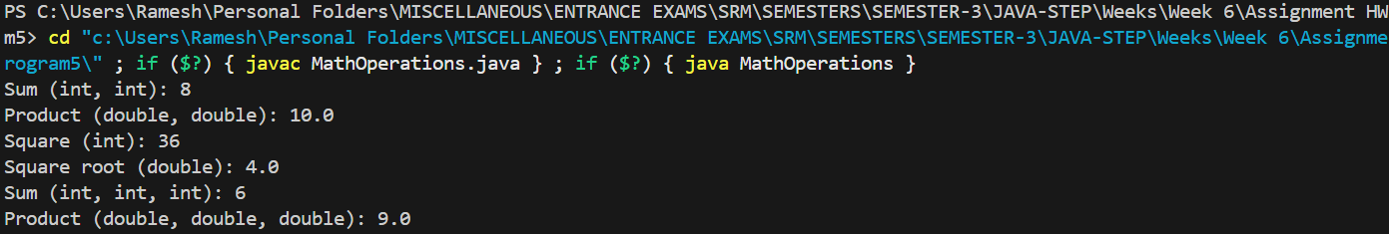

**QNO 6🡪**

**Problem Statement:**

**Create Weather → Storm → Thunderstorm (multilevel) and Weather → Sunshine**

**(hierarchical). Include constructor chaining, method overriding, and polymorphism.**

**Hints:**

**● Implement both multilevel and hierarchical inheritance**

**● Use constructor chaining throughout**

**● Override methods at different levels**

**● Test with polymorphic array of Weather references**

**PROGRAM🡪**

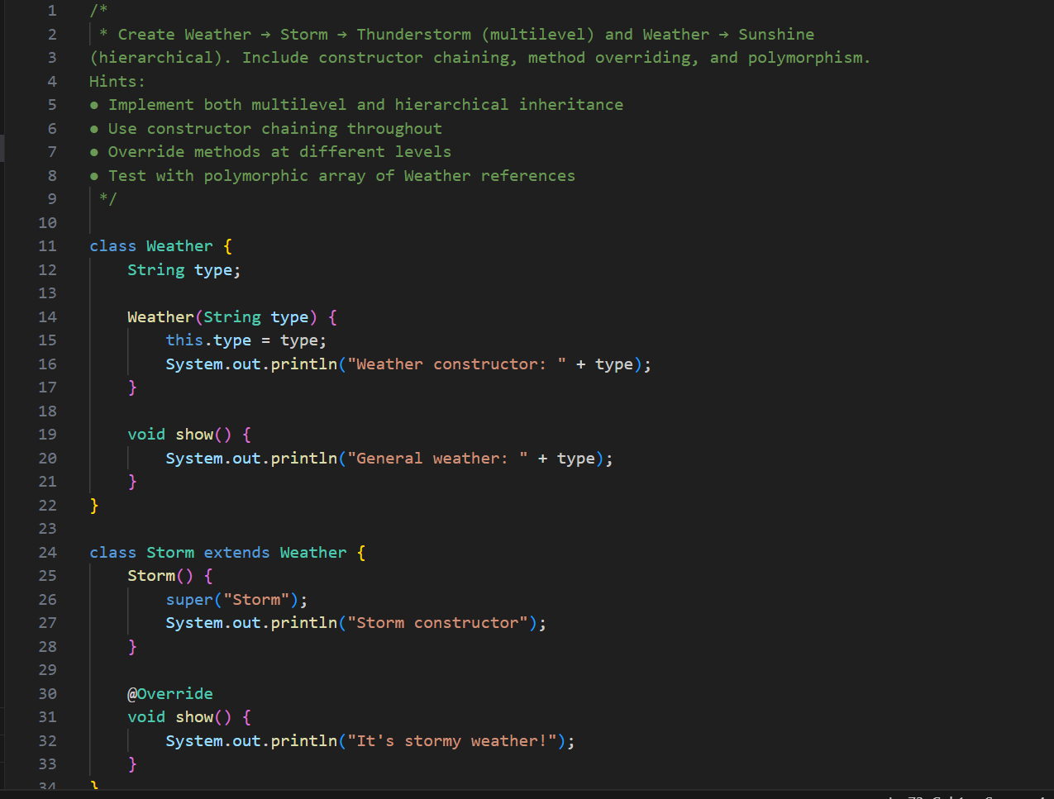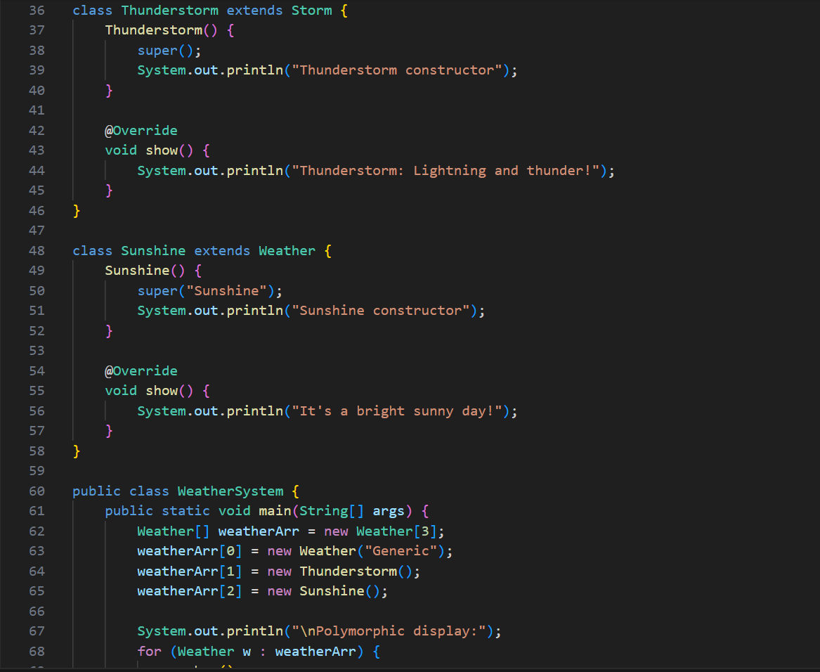

**OUTPUT🡪**